PRESS RELEASE
FOR IMMEDIATE RELEASE

NECO CONTACT: Lauri Morrow Crawford
Mobile Phone: +1.817.807.5463
Email: crawfordl@neco.edu

OR Abigail Michaud
Mobile Phone: +1.207.831.7358
Email: michauda@neco.edu

Tactile Learning Finds Home at NECO Center for Eye Care
NECO presents alternative ways to understand how we see.
BOSTON, MA, November 3, 2023 – The New England College of Optometry (NECO) Center for Eye Care has a new interactive experience featuring a tactile image of the visual system on display at 930 Commonwealth Ave. A tactile image allows touch and sound to stimulate a sensory experience for the brain to create a visual image that allows a person to ‘see’. The visual system is complex, but this learning tool helps individuals understand the inner-workings of the brain that create a visual understanding of the world.
This unique piece will bring an understanding of the human experience to individuals regardless of their visual ability. Being able to touch, feel, and hear the depiction of the eye lets users come to their own understanding without someone else explaining it to them.
This exceptional teaching tool was generously donated by former Commissioner of the U.S. Rehabilitation Services Administration and NECO Board Member Janet LaBreck, for whom NECO’s Low Vision Center is named. In collaboration with Tactile Images, a New York-based company specializing in accessible educational and artistic installations, this kinesthetic experience teaches audiences both about the eye and the many ways in which individuals gather information.
“The collaborative partnership between Tactile Images and NECO to develop a technological solution to educate the patient community and their family members about the visual system is truly a transformative experience,” said LaBreck. “We are encouraged that it will allow for a holistic way to promote independent access to what would traditionally be considered visual information.”
The ceremony unveiling this one-of-a-kind tactile display welcomed members from the Massachusetts Commission for the Blind, NECO leadership and low vision faculty, LaBreck and her team, and Tactile Images’ Co-Founder John Olson and Senior Creative Officer and Vice President of Marketing Brad LaMere. NECO President and CEO Dr. Howard Purcell along with NECO Center for Eye Care Senior Director Owned Clinics and Outreach Affiliations Dr. Timothy Bossie both noted the importance of this piece and the impact they expect.

- More -

Page two

“It is our hope that this functional learning tool will aid not only our patient’s understanding of the eye, but also support our clinical optometrists in teaching patients and students how the eye functions,” shares Dr. Bossie. “We are excited to share this tactile depiction of the visual system as an additional way to help people understand their world.”
Being able to gather knowledge through alternative means, such as touch, is an important initiative for organizations to support because the National Eye Institute expects adults with vision impairment or blindness to double by 2050. The growing number of individuals living with vision impairment is a call for people to seek further understanding of their sight, how to protect their vision, and the need for alternative learning options that span beyond the standard visual learning tools.
“By presenting visual information in alternative ways, tactile images help to provide all users a firsthand connection to knowledge that may otherwise be inaccessible to individuals with vision loss,” explains John Olson, Co-Founder of Tactile Images.
NECO Center for Eye Care is excited to have this learning tool in a broadly accessible space and is confident that it will have a positive impact on anyone who interacts with it. From students learning about the anatomy of the eye, to patients understanding their diagnosis, this tool will support the journey of different users in understanding vision and how they see the world.
###

ABOUT NECO
New England College of Optometry is a private, nonprofit, and internationally recognized optometry school. We prepare the next generation of eye care providers, educators, and innovators through rigorous curriculum, extensive clinical experiences, state-of-the-art facilities, and a strong support network. As an independent optometry school, we focus solely on optometry. Founded in 1894, NECO is the oldest continuously operating optometry school in the U.S. and has been advancing optometric education ever since.

PHOTOS FOLLOW
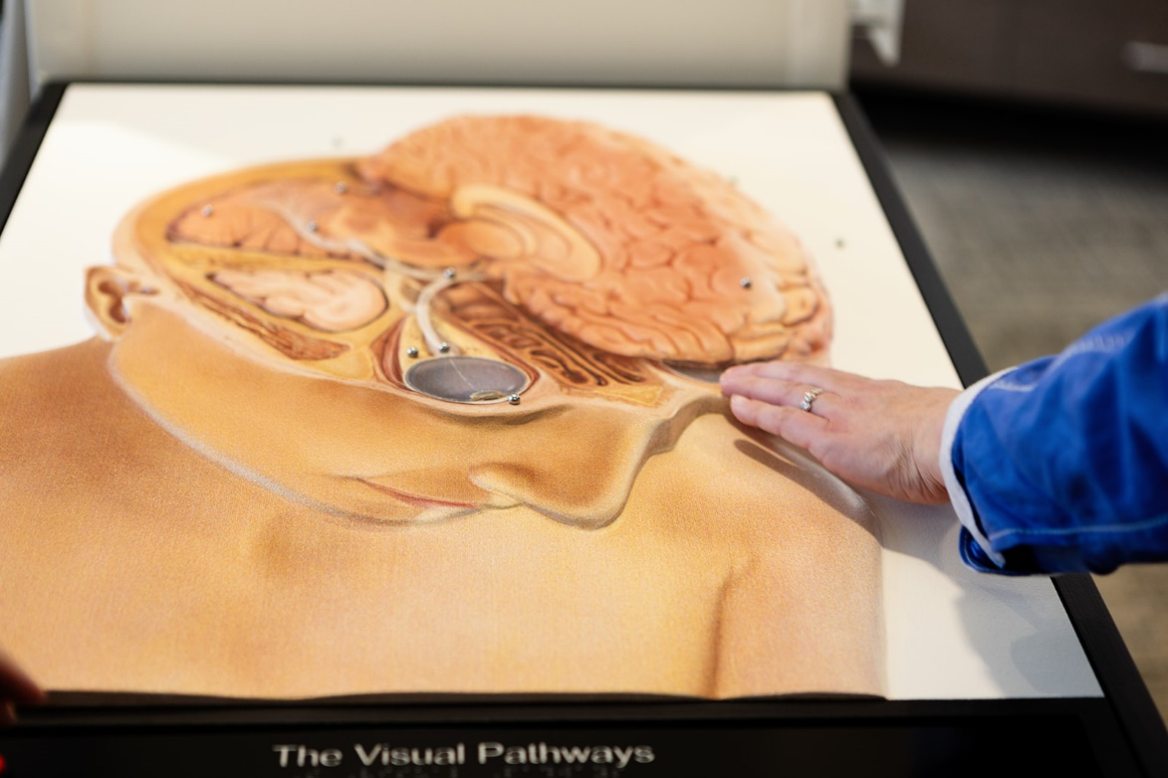

Tactile Image Closeup

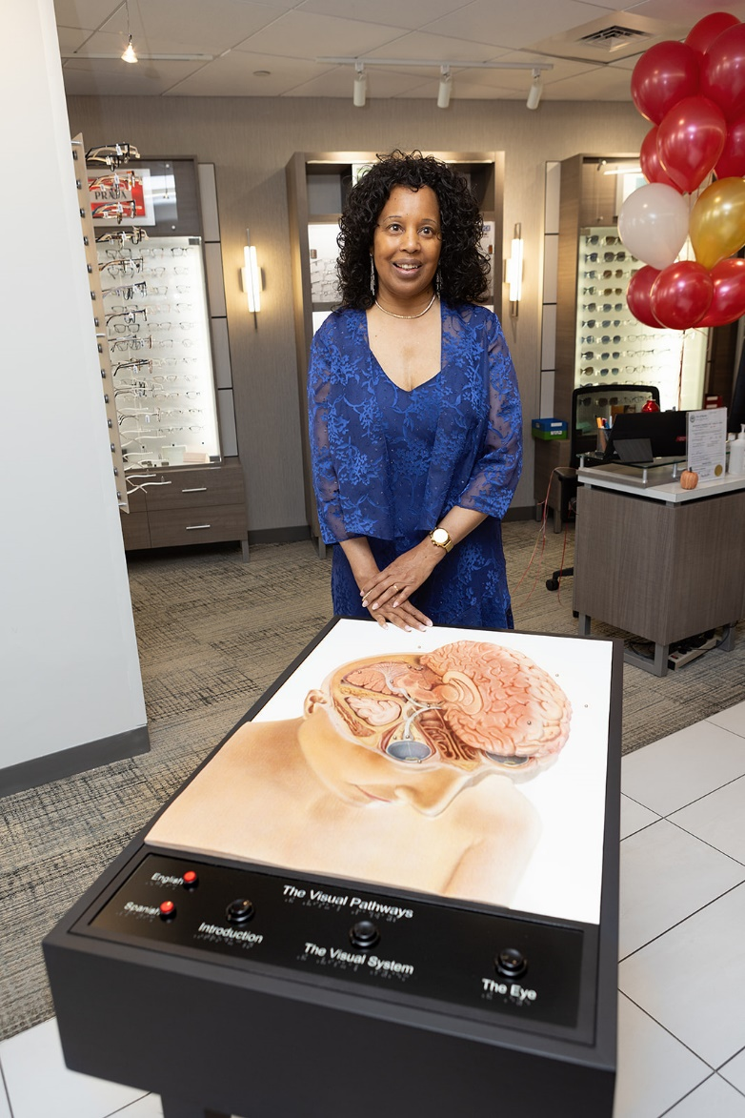
Janet LaBreck with the tactile image she generously
donated to the NECO Center for Eye Care.

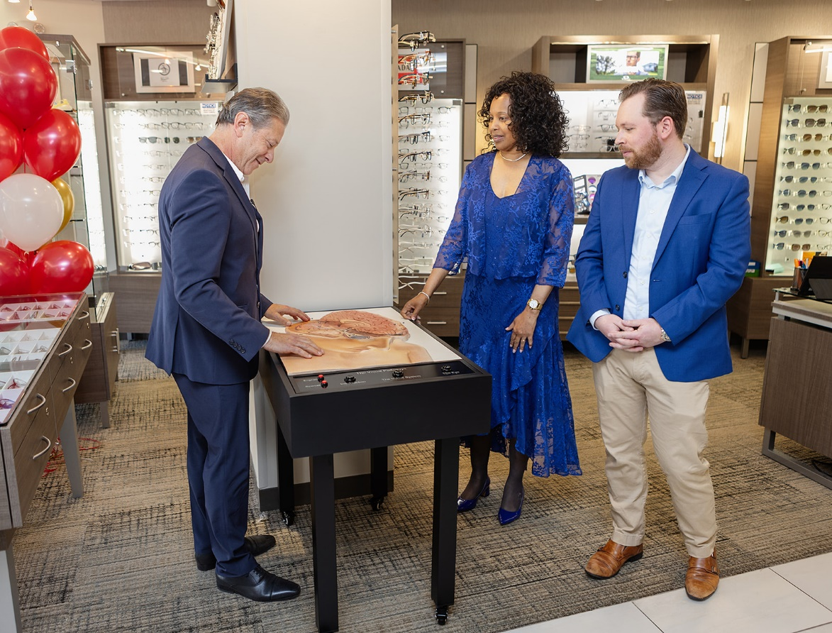
Dr. Howard Purcell sees the tactile image for the first time with
Janet LaBreck and Brad LaMere

From left to right: Dr. Timothy Bossie, Dr. Howard Purcell, Janet LaBreck,
John Olson, and Brad LaMere

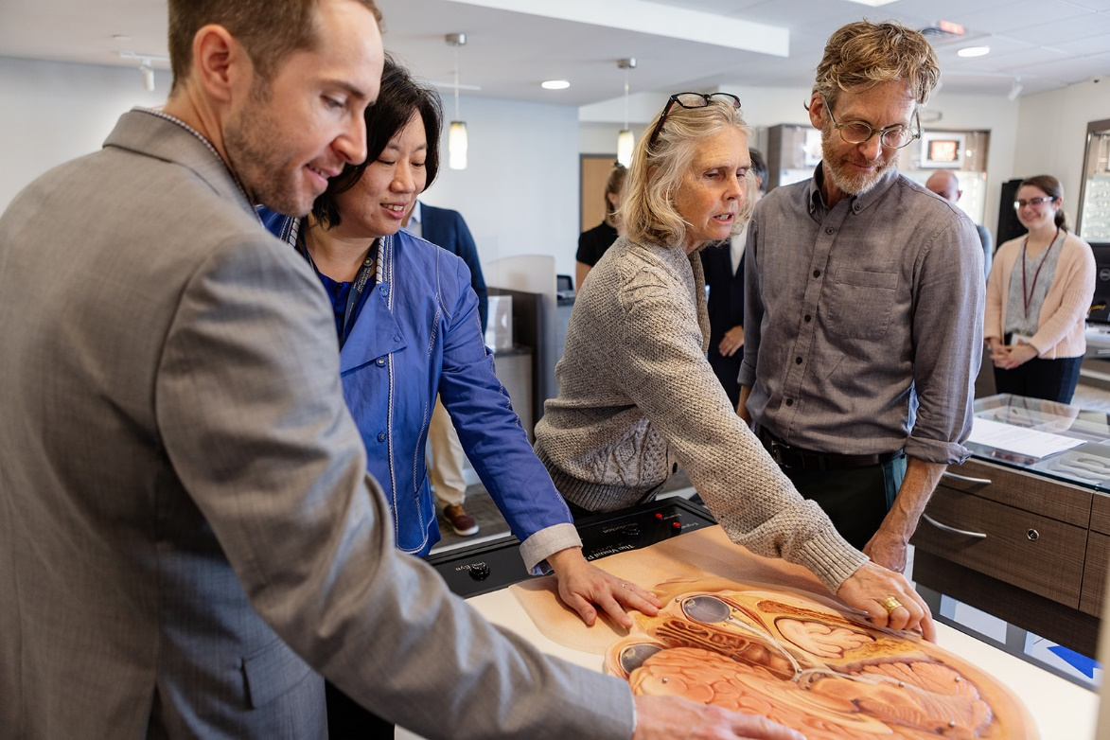

Dr. Timothy Bossie, Dr. Amy Moy, Traci Logan, and Dr. Erik Weissberg talk about how to engage patients and expand their understanding of the visual system.

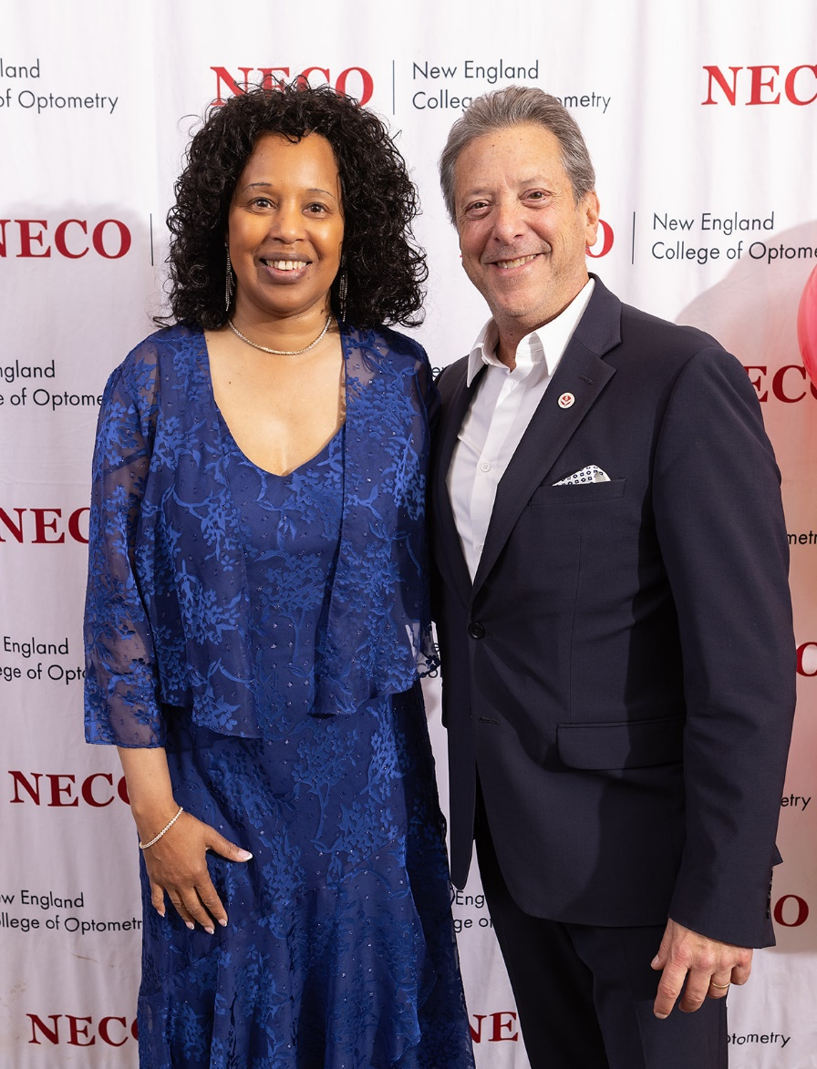
Janet LaBreck and Dr. Howard Purcell

